Some specific wish-list items for LAMS system administrators

The System Administrator environment has a variety of features. Two of these features are particularly useful: importing users and importing groups. Figures 1 below provide screenshots of the import user function.

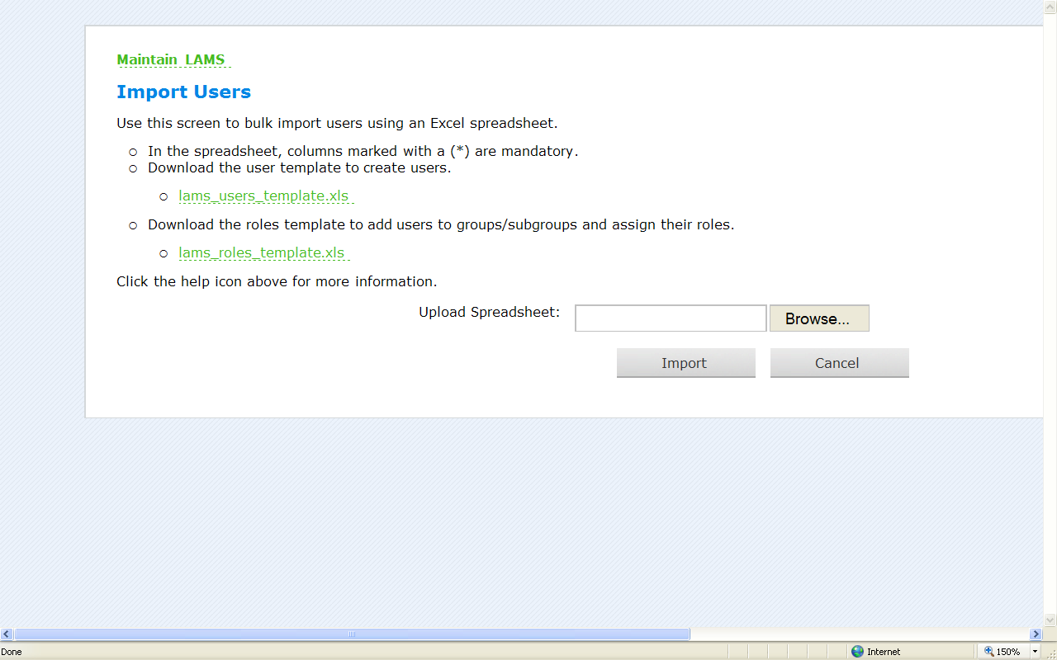
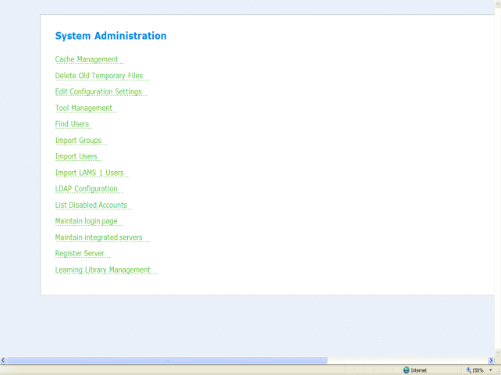

Figure 1 Screenshots of the import user function within the System Administrator environment.

To mass create user accounts a 20-column user template spreadsheet (lams_users_template.xls) is required that has mandatory Login, password, first name, last name and email sections. Figure 2 presents an example row of this spreadsheet. A further spreadsheet (lams_roles_template.xls) is used once accounts have been created, to assign users to their groups and/or subgroups. However, it is hoped that this extremely useful function might be simplified within the settings of a specially developed more user-friendly/supportive LAMS data-entry program.

Figure 2 An example row of the LAMS user-import spreadsheet

System Administrators presently do not have access to teacher lessons; however it would be useful if they could transfer lessons or whole lesson-sequence files between individual teachers directly. Moreover it would be supportive if System Administrators could periodically mass export all lesson sequences to an external mass storage device for strategic data storage. Another ‘wish list’ request pertains to the usefulness of some form of instant messaging between System Administrator(s) and teachers and/or students; for instance, for the purpose of informing everyone that there would be scheduled server-work interruptions to LAMS. It is not yet apparent however whether LAMS 2.3 will have such administrator instant messaging capabilities. A further ‘wish list’ request concerns the act of moving LAMS data to a dedicated and more powerful server; at The University of Nicosia, this was found to be problematic with regard to finding and transferring picture files. Therefore there may be an issue with making it easier to transfer picture-file data from one server to another. Furthermore, removing lesson sequences completely from a teacher’s lesson page does not appear to be possible/straightforward in spite of the fact that no students have been logged into them and/or created to use them. Figure 3 for instance shows a case where a teacher wanted to do a ‘clean-up’ by actually removing all the sample lessons from his test group but could not do so. It is suggested that System Administrators (and also teachers) should be given such powers.

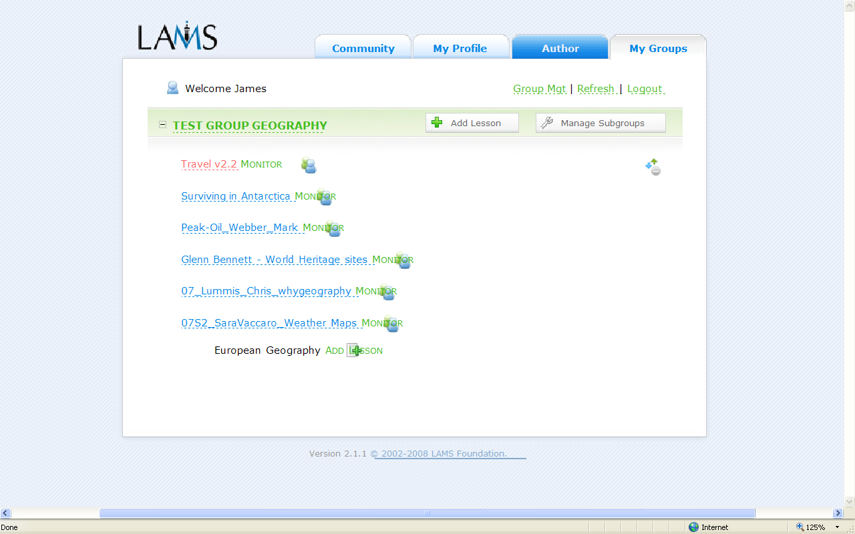
Cannot remove/not clear how to remove empty-student group lessons that have been added here (sometimes by accident)

Figure 3 A screenshot of lessons that could not be removed

The difference between Course Manager and Course Administrator is explained here; however the system administrators currently can allow users to have both roles. This may create confusion for users who have been given both roles.

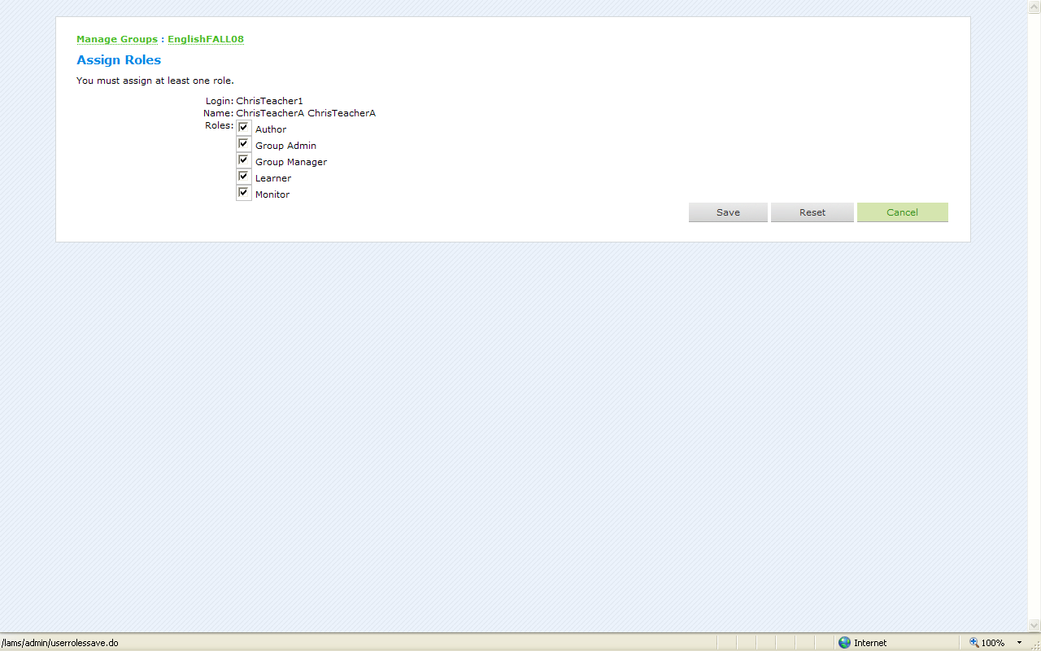
ALSO NOTE: Course Managers or Course Administrators should not be allowed to take such privileges away from themselves without a warning window. This sometimes happens by ‘accident’, which means System Administrators have to reset roles.

Figure 4 a screenshot of the assigning roles window
Some specific wish-list items for LAMS Author/Monitor/Learner/Course Managers

The Author/Monitor/Course Manager Home ‘My Groups’ Page (Figure 5) has numerous useful features.
NOTE: it would be helpful for Learners and Monitors to have the dates/ times indicated for scheduled lessons

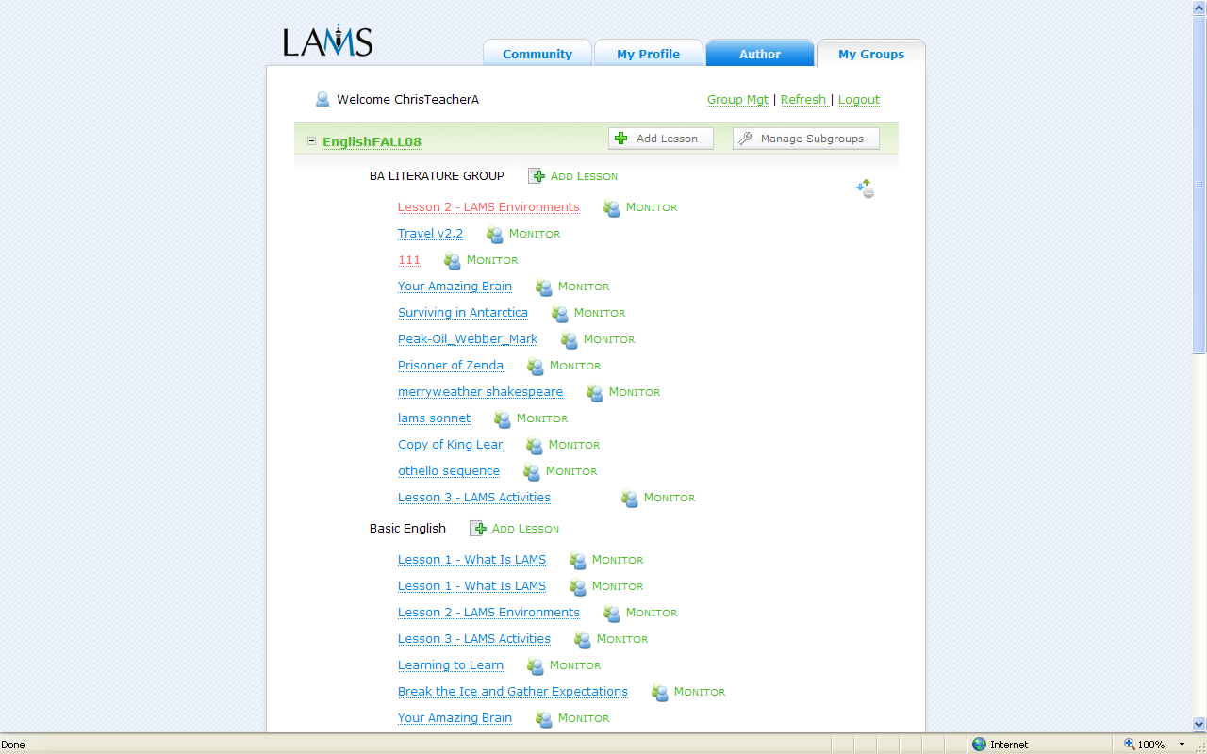
NOTE: it would be useful to have a ‘quick-view’ indication from this page of how many Learners and/or which Learners were currently doing a particular sequence

Figure 5 A screenshot of the Teacher/Monitor ‘My Groups’ Page with comments

However having a more interactive Author/Monitor/Group Manager ‘My Groups’ Page (Figure 5) environment would also be desirable; for example: (a) sequences could be moved into files more freely; (b) colours/graphics/fonts could be changed according to preference; (c) archived/removed lessons could be moved freely into separate files. Another ‘wish list’ item refers to whether it is technically feasible to have more than one Monitor; this would be of use for groups that have more than one teacher. Moreover it would be of use (if technically practicable) to have a teacher email address book and emailing capabilities within LAMS; this would enable easier sharing of materials by sending lesson sequences directly to other teachers. Presently lessons have to be exported, sent to a teacher and then re-imported.

Some other more general points include: (1) incorporating an explanatory animation of whether/how ‘Journal Entries’ can be used LAMS 2.1.1; (2) improving the powerful Submit Tool to allow teachers to also send the corrected student assignment back to the student with grade and comments; (3) using user-friendly warning messages within LAMS (if possible) that inform/warn LAMS users of any updates that are required (e.g. for Internet Explorer, Mozilla Firefox); (4) introducing an automatic Refresh capability (if possible) for Learners and Monitors; (5) having a Find Student function from the Teacher/Monitor ‘My Groups’ Page (Figure 5) for Course Managers/Monitors that could enable quicker access to student work (e.g. amount of time spent on a sequence and whether any submissions have been made); (6) Popup bars for some users being confusing. It would be helpful if they could automatically be eliminated (see Figure 8); (7) Branching, which is a potent tool with a growing number of features: (e.g. Teacher-Selected Branching, Grouping-Based Branching, Tool-Output Branching). However, from a pedagogic perspective the linear progression of Branching tool activities (could also) suggest some form of group research. Therefore, arguably, a ‘specialised’ Branch ‘dissemination’ (e.g. Forum/Chat) Outcome tool would be advantageous to complement Branch; (6) giving Monitors access to the amount of time students had spent on sequence items would also be an invaluable addition to Monitor.

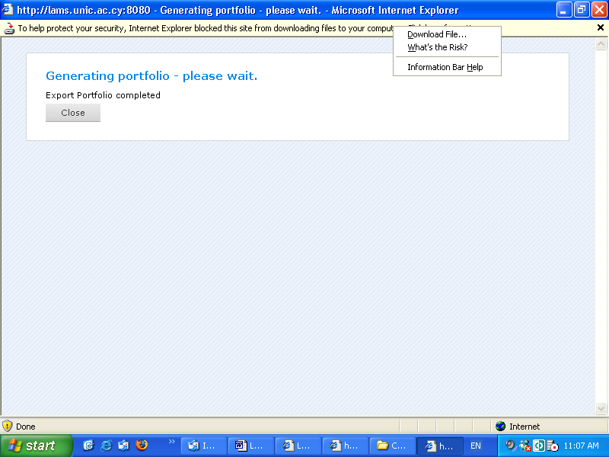
NOTE: pop ups may be confusing for LAMS users

Figure 6 Pop-ups in LAMS may be confusing

Another thought concerns the WINZIP format of the individual and group Export Portfolio function in Monitor mode (Figure 7).

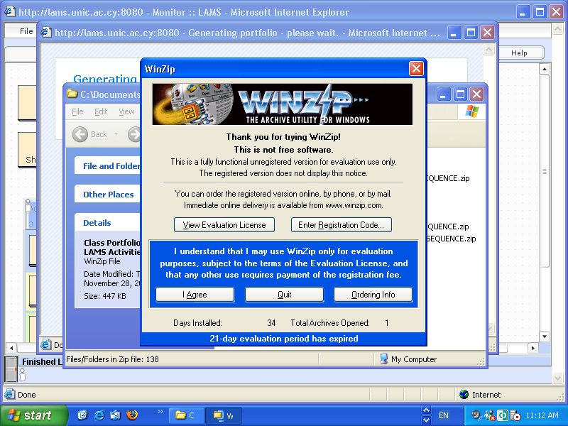
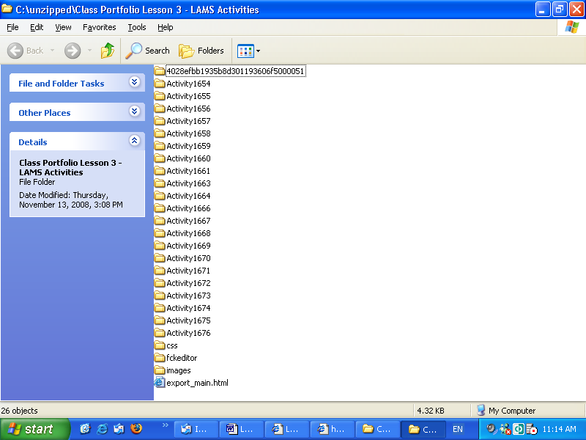

NOTE: this is the link to click

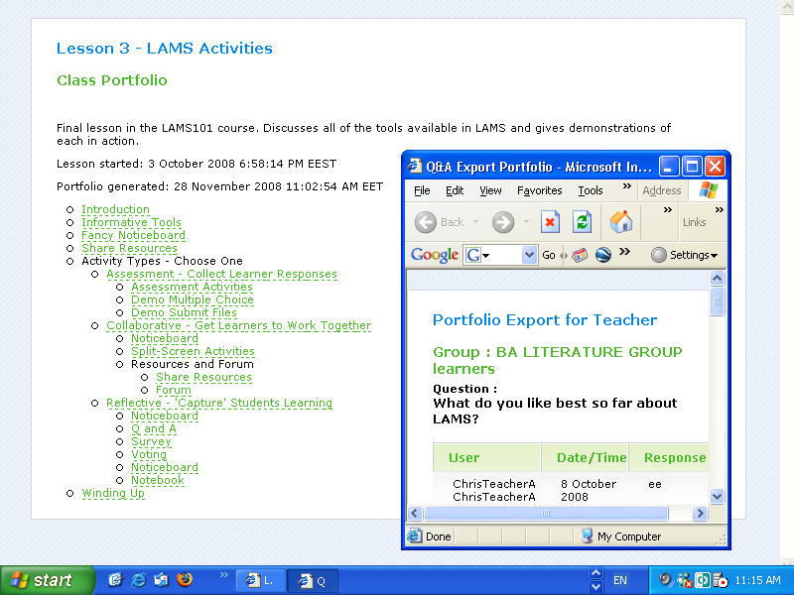
NOTE: Could the procedure of Exporting Portfolios be simplified?

NOTE: Student work

Figure 7 Exporting Portfolios

It is also recommended that more collaborative tools such as individual/group student Skype-like real-time collaboration or voice chat/forum options be brought into future versions of LAMS if this is technically feasible. Such tools could provide real-time face-to-face contact which might significantly upgrade learning potential and afford a new complementary dimension to the written Chat and Forum tools. Further to the suggestion regarding Skype-like real-time collaboration options being brought into future versions of LAMS, it is held that the following specific features might significantly enhance the e-learning experience: (i) teacher individual or grouped Skype-like ‘scheduled’ contact with students; (ii) student to student Skype-like individual or grouped contact with each other during a sequence This kind of function would allow a more ‘private’ form of collaboration between lesson participants. Furthermore, this might entail giving students extra ‘powers’ to view who else was working online, which in itself could be an appealing Learner feature to introduce.

