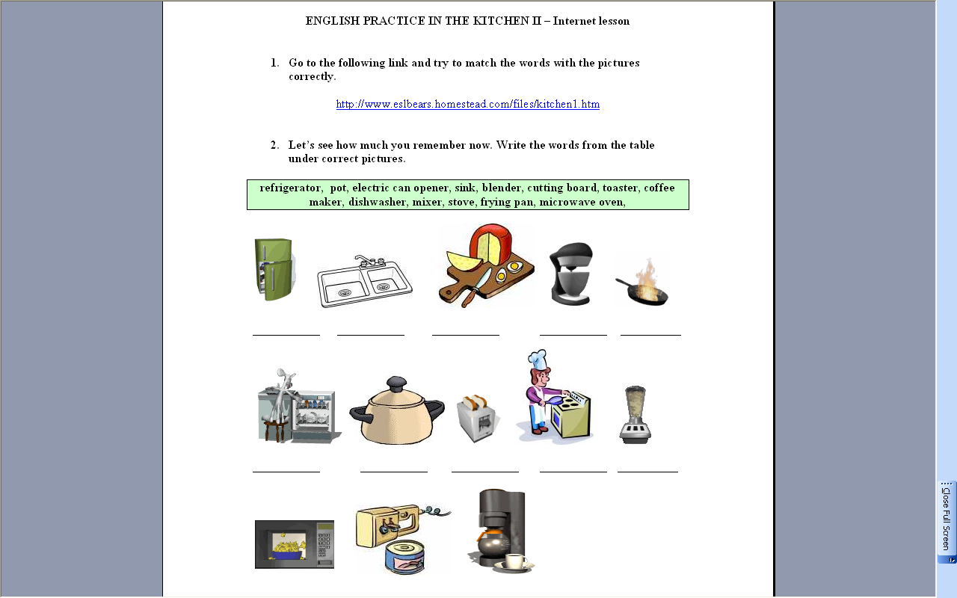
The lesson combines ICT and non-ICT teaching. If there is unreliable Internet connection, students can do the non-ICT exercises

The teacher can retain many of her traditional roles and methodologies e.g. monitor / regulate learning or pair/group work. Students may want/expect to be taught more traditionally without being given so much autonomy.

Sites are suitable level-wise (i.e. grammar/vocabulary) and topic-wise.
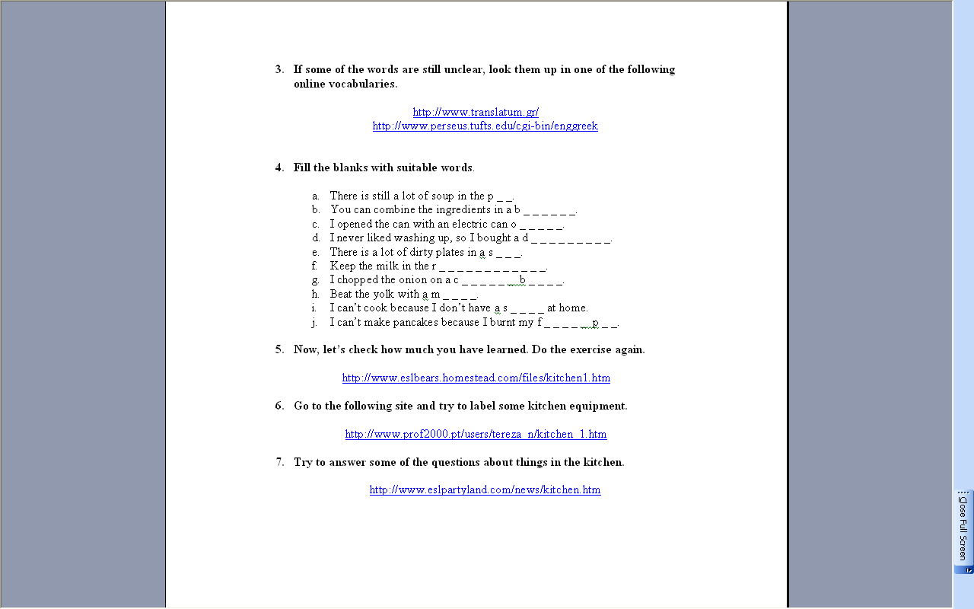
The lesson has a core set of sites i.e. it does not rely on one site and/or use too many sites. Moreover the lesson provides additional Internet work for students that finish earlier.

Even though the lesson is focused on vocabulary and spelling of vocabulary, pronunciation skills could be practised. Moreover, a speaking, listening, grammar and writing component could be built into the lesson. This would broaden the scope of Internet learning.

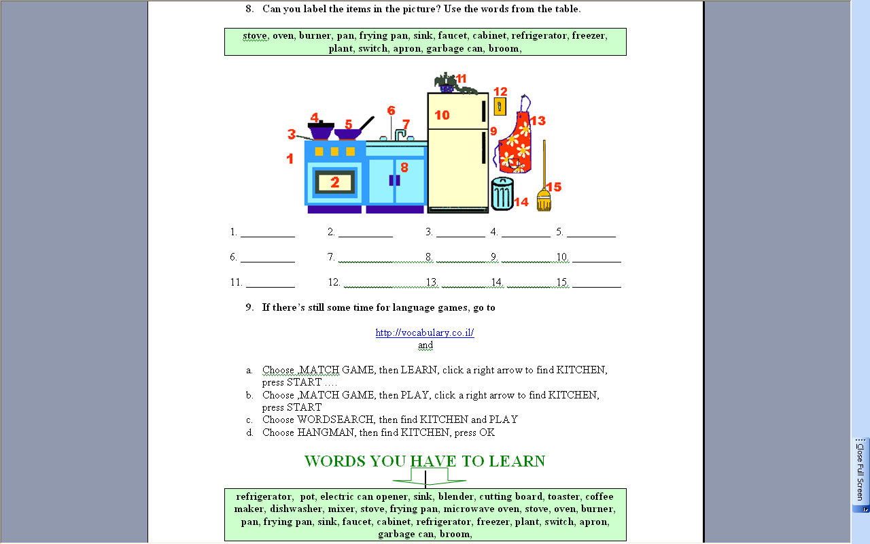
All the vocabulary used in the ICT part is used in the non-ICT part i.e. no new vocabulary is introduced. Moreover, materials have been timed/sequenced so as to create a balance between ICT/non-ICT learning.

The sites clearly have been pre-screened so a teacher could explain to students what should be done.

There is a clear connection with course exam i.e. students know what words they have to learn; attainment may be measured.

Plate 1 An example of sound Internet pedagogy

