IN THE KITCHEN II – Internet lesson

- Go to the following link and try to match the words with the pictures correctly.

http://www.eslbears.homestead.com/files/kitchen1.htm

- Let’s see how much you remember now. Write the words from the table under correct pictures.

refrigerator, pot, electric can opener, sink, blender, cutting board, toaster, coffee maker, dishwasher, mixer, stove, frying pan, microwave oven,

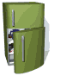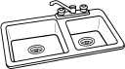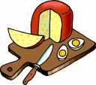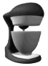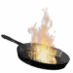

__________ __________ __________ __________ _________

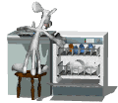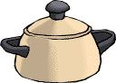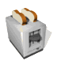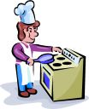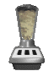

__________ __________ __________ __________ _________

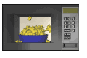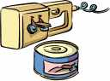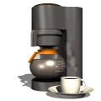

__________ ___________ __________

- If some of the words are still unclear, look them up in one of the following online vocabularies.

http://www.translatum.gr/
http://www.perseus.tufts.edu/cgi-bin/enggreek

- Fill the blanks with suitable words.

  - There is still a lot of soup in the p _ _.
  - You can combine the ingredients in a b _ _ _ _ _ _.
  - I opened the can with an electric can o _ _ _ _ _.
  - I never liked washing up, so I bought a d _ _ _ _ _ _ _ _ _.
  - There is a lot of dirty plates in a s _ _ _.
  - Keep the milk in the r _ _ _ _ _ _ _ _ _ _ _ _.
  - I chopped the onion on a c _ _ _ _ _ _ b _ _ _ _.
  - Beat the yolk with a m _ _ _ _.
  - I can’t cook because I don’t have a s _ _ _ _ at home.
  - I can’t make pancakes because I burnt my f _ _ _ _ _ p _ _.

- Now, let’s check how much you have learned. Do the exercise again.

http://www.eslbears.homestead.com/files/kitchen1.htm

- Go to the following site and try to label some kitchen equipment.

http://www.prof2000.pt/users/tereza_n/kitchen_1.htm

- Try to answer some of the questions about things in the kitchen.

http://www.eslpartyland.com/news/kitchen.htm

- Can you label the items in the picture? Use the words from the table.

stove, oven, burner, pan, frying pan, sink, faucet, cabinet, refrigerator, freezer, plant, switch, apron, garbage can, broom,

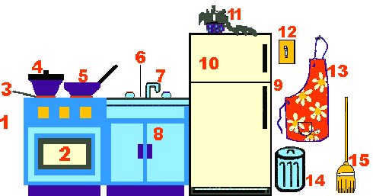

1. __________ 2. __________ 3. _________ 4. _________ 5. _________

6. __________ 7. __________ 8. _________ 9. _________ 10. _________

11. _________ 12. _________ 13. ________ 14. ________ 15. _________

- If there’s still some time for language games, go to

http://vocabulary.co.il/
and

- Choose ,MATCH GAME, then LEARN, click a right arrow to find KITCHEN, press START ….
- Choose ,MATCH GAME, then PLAY, click a right arrow to find KITCHEN, press START
- Choose WORDSEARCH, then find KITCHEN and PLAY
- Choose HANGMAN, then find KITCHEN, press OK

WORDS YOU HAVE TO LEARN

refrigerator, pot, electric can opener, sink, blender, cutting board, toaster, coffee maker, dishwasher, mixer, stove, frying pan, microwave oven, stove, oven, burner, pan, frying pan, sink, faucet, cabinet, refrigerator, freezer, plant, switch, apron, garbage can, broom

