- Go to the Internet site below and get familiarised with some food vocabulary. Remember to do all exercises.

http://www.manythings.org/lulu/c1.html

Make sure that after doing all the exercises you can name the following items:

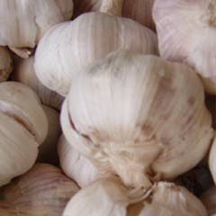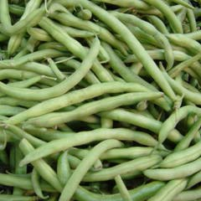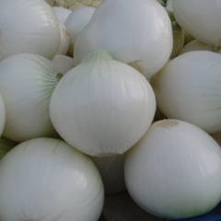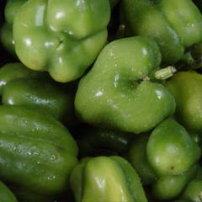

_________ __________ ___________ ___________

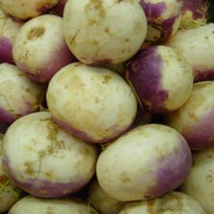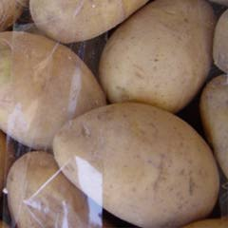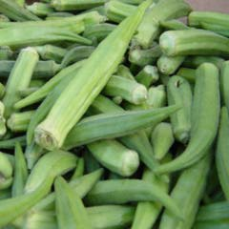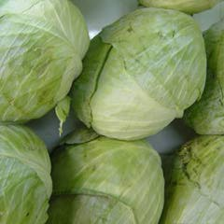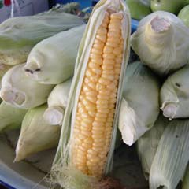

__________ __________ __________ __________ __________

2. Go to the picture online dictionary (http://www.pdictionary.com/english/browse.php?db=vegetables) and find names of the following vegetables.
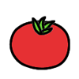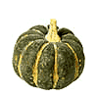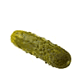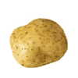
___________ ___________ ___________ ___________ ___________
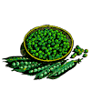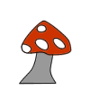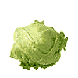
____________ ____________ ___________ __________ _____________
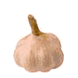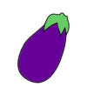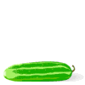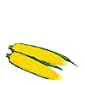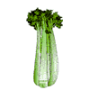
______________ __________ ____________ _____________ ____________

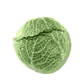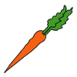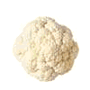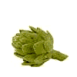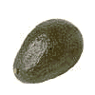
___________ ____________ _____________ ___________ _____________
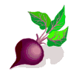
_____________
- What are the vegetables in this site (http://a4esl.org/q/h/vc-vegetables-lb.htm)?

- Do you know enough vegetables to solve the crossword puzzle that you can find in this site (http://iteslj.org/cw/1/vm-vegetables.html )?
- Solve a puzzle in the following site (http://www.manythings.org/wf/2/vegetables.html).
- Improve your spelling.
http://www.manythings.org/cts/8987.html
This vocabulary will be required for your mid-term and final
Potatoes, garlic, cabbage, green peas, turnips, corn, onions, okra, green beans, artichoke, avocado, beet, carrot, cauliflower, celery, cucumber, eggplant, hot pepper, lettuce, mushroom, pickle, red pepper, squash, tomato

