IN A DINING ROOM– Internet lesson

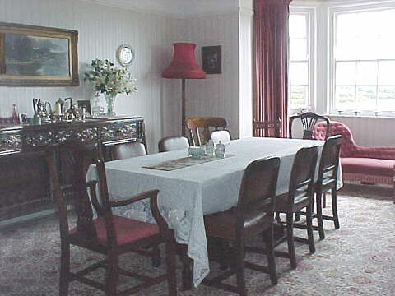
- Click on the following link and check how many words you already know.

http://www.eslbears.homestead.com/files/dining.htm

- Let’s see how much you remember now. Write the words from the table under correct pictures.

Cup, glass, knife, bowl, salt shaker, fork, pepper shaker, spoon, napkin, candle, teapot, plate,

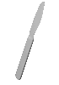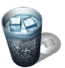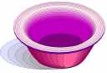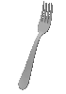

__________ __________ __________ __________

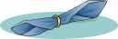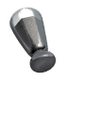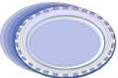

__________ __________ __________ __________

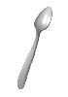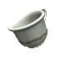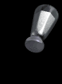

__________ __________ __________ __________

- If you still are not sure about what the words in exercise 2 mean, go to the English-Greek dictionary and look them up.

http://www.translatum.gr/
http://www.perseus.tufts.edu/cgi-bin/enggreek

- Complete the sentences.

- Light a c _ _ _ _ _ and we will have a romantic atmosphere.
- I want to cut the meat. Give me a k _ _ _ _ _.
- Pour some Coke into a g _ _ _ _.
- I pour tea from a t _ _ _ _ _ into a c _ _.
- I need some salt in my salad. Could you pass me the salt s _ _ _ _ _.
- Is there any pepper in a pepper s _ _ _ _ _?
- I’m thirsty. I need to drink a g _ _ _ _ of water.
- She has a nice salad in her b _ _ _.
- My little sister doesn’t know how to use a knife and f _ _ _ . She eats with her hands.
- Put a n _ _ _ _ _ on your lap, if you don’t want to stain your trousers.

- Do the online exercise once again and see how much you learned today☺.

http://www.eslbears.homestead.com/files/dining.htm

- Now, it’s time for something difficult. Go to the following site

http://perso.wanadoo.fr/wulles/english/college/maison/pageshtm/maison5.htm
and fill the blanks.

You can use the words given below.

on the left, are, chairs, dining, table, armchairs, white, on, cupboard, wall, is lamp, chair, window, sofa, pink, middle, carpet, next to, in
Words to remember:

cup, glass, knife, bowl, salt shaker, fork, pepper shaker, spoon, napkin, candle, teapot, plate

Copyright © 2006 Katarzyna Rysiewicz- all rights reserved

