FRUITS

- Go to the online picture dictionary (http://www.pdictionary.com/english/browse.php?db=fruits) and find the names of the items below.

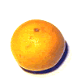

_____________ ____________ _____________ ____________ _____________

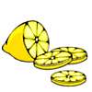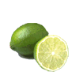
______________ ____________ ___________ ____________ ____________

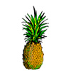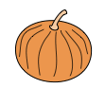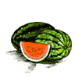
_____________ _____________ ____________ _____________

- Do you know enough fruit names to solve this crossword puzzle (http://iteslj.org/cw/1/ck-fruit.html)?

- How about this puzzle (http://www.english-zone.com/vocab/v-fruit.html)? Can you solve it?

- Now, it is time for a couple of anagrams…

http://a4esl.org/q/h/vm/sw-fruits.html

- Now try to find names of fruits in a box full of letters.

http://www.manythings.org/wf/3/fruit.html

- To work on your spelling, go the site below.

http://www.manythings.org/cts/8987.html

- If you completed all the above tasks, you can play hangman for a while.

http://www.englisch-hilfen.de/php/hangman9_e/index.php

AND HERE ARE THE VOCABULARY ITEMS YOU NEED TO KNOW FOR YOUR EXAMS

apple, banana, cherry, coconut, grapefruit, grapes, lemon, lime, orange, pear, pineapple, pumpkin, strawberry, watermelon, kiwi, peach

