FOOD AND DRINKS 1 – Internet lesson

- Go to the internet site below and get familiarised with some food vocabulary. Remember to do all exercises.

http://www.manythings.org/lulu/f3.html

- Go to the following site to learn even more vocabulary.

http://www.manythings.org/lulu/g3.html

- The following quiz will help you to memorise another group of words.

http://www.englishclub.com/esl-quizzes/vocabulary-1-food.htm

- The “Catch the Spelling” game will help you with spelling. Enjoy it!

http://www.manythings.org/cts/hm-food-drink.html

- Remember that you have to know all the vocabulary below; especially for quizzes and exams.

Toast, fruit, pizza, ice cream, orange juice, vegetable, wine, carrot, coffee, salad, orange, pear, strawberry, milk, egg, hamburger, potato, lemon, grapes, French fries, banana, onion, chocolate, cherries, garlic, cake

Try to see how much you remember now!

Do the exercise yourself for better results.

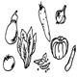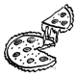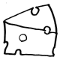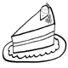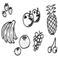
_ _ _ _ _ _ _ _ _ _ _ _ _ _ _ _ _ _ _ _ _ _ _ _ _ _ _ _ _ _
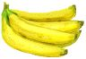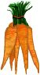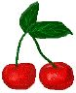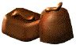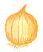
_ _ _ _ _ _ _ _ _ _ _ _ _ _ _ _ _ _ _ _ _ _ _ _ _ _ _ _ _ _ _ _ _ _ _

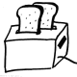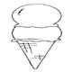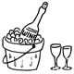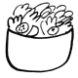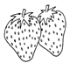
_ _ _ _ _ _ _ _ _ _ _ _ _ _ _ _ _ _ _ _ _ _ _ _ _ _ _ _ _ _ _ _

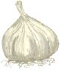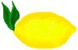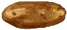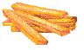
_ _ _ _ _ _ _ _ _ _ _ _ _ _ _ _ _ _ _ _ _ _ _ _ _ _ _ _ _ _ _ _ _ _

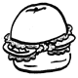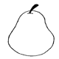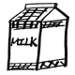
_ _ _ _ _ _ _ _ _ _ _ _ _ _ _ _ _ _ _ _ _ _ _ _ _ _
_ _ _ _ _ _ _ _ _ _ _Bottom of Form


          

