CLOTHES

- Go to the following link and do the series of exercises from “Matching” to “Pairs”.
http://www.manythings.org/lulu/q3.html
- Label the pictures. One line is one letter.
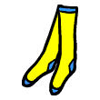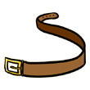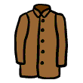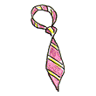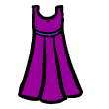
_ _ _ _ _ _ _ _ _ _ _ _ _ _ _ _ _ _ _ _ _
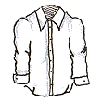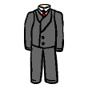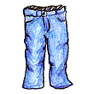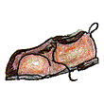
_ _ _ _ _ _ _ _ _ _ _ _ _ _ _ _ _ _ _

- Go to the following site and do all the exercises starting from “Matching” to “Pairs”.
http://www.manythings.org/lulu/r1.html

- Try to solve this crossword puzzle.

ACROSS | DOWN
1. 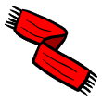 4. 7. 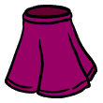  8. 9. 11.  15. 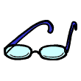16.  | 2. 3. 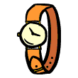4. 5.  6. 7. 10. 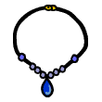12. 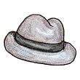  13. 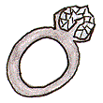14. 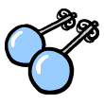

 |  | ¹ | ² |  |  |  |  |  | ³ |  |  | ⁴
 | ⁵ |  |  |  |  |  | ⁶
 |  |  |  |  | ⁷
⁸ |  |  |  |  |  |  |  |  |  |  | ⁹ |  |  | ¹⁰
 | ¹¹ | ¹² |  | ¹³
 | ¹⁴ |  |  | ¹⁵
¹⁶

- Go to the following site and do the matching exercise.
http://www.eslbears.homestead.com/files/clothing.htm

- Match the pictures with the words from the table.
raincoat, purse, cap, gloves, shorts, wallet, sweater, pants, t-shirt, shirt, umbrella, blouse, jacket,

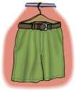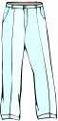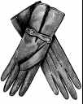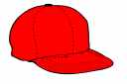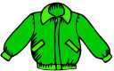
__________ __________ __________ __________ __________
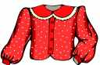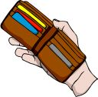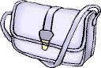
__________ __________ __________ __________
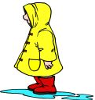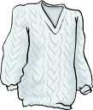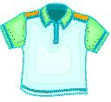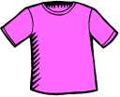
__________ __________ __________ __________
7. Go to the following site and do the matching exercise.
http://iteslj.org/v/ei/clothes.html

HOW TO DESCRIBE WHAT PEOPLE WEAR
I am wearing a red hat. You are wearing blue jeans. He is wearing a yellow t-shirt.
She is wearing a green dress. We are wearing black shoes. They are wearing purple ties.
- Look at the picture and complete the description.
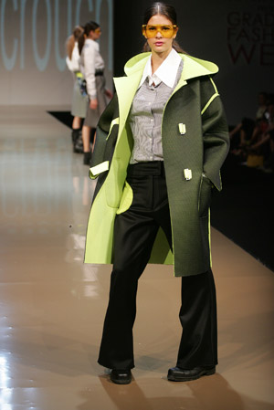
coat, shoes, trousers, glasses, green, white, shirt
This girl is wearing yellow and __________ __________. She has got grey and __________ __________. She is wearing black __________ and black __________. The girl has got yellow __________.

- Write what these people are wearing.
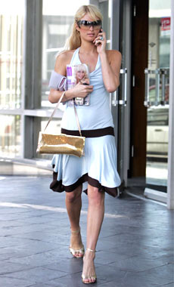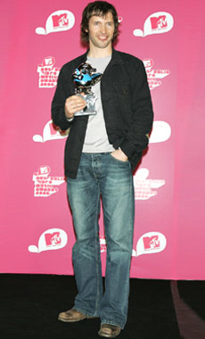
………………………………………………………………………………………………
………………………………………………………………………………………………
………………………………………………………………………………………………
………………………………………………………………………………………………
………………………………………………………………………………………………
………………………………………………………………………………………………
………………………………………………………………………………………………
………………………………………………………………………………………………
………………………………………………………………………………………………
………………………………………………………………………………………………
belt, coat, dress, jeans, shirt, shoes, socks, suit, tie, bracelet, earrings, glasses, hat, necklace, ring, scarf, skirt, watch, blouse, raincoat, gloves, sweater, t-shirt, wallet, purse, pants, jacket, cap, umbrella, shorts,

