BEDROOM AND BATHROOM
- Go to the following site and try to do the matching exercise.
http://www.eslbears.homestead.com/files/bathroom1.htm

- Match the words from the table with appropriate pictures.

hamper, toilet paper, mirror, toothbrush, toothpaste, bathtub, shower, sink, scales, faucet, towels, soap, medicine cabinet, toilet, tile,
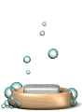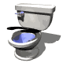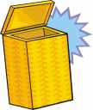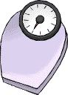
__________ __________ __________ __________ __________
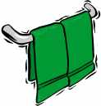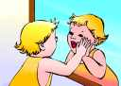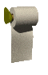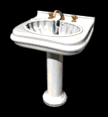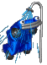
__________ __________ __________ __________ __________
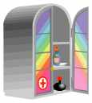 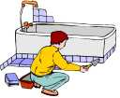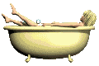 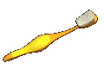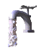__________ __________ __________ __________ __________

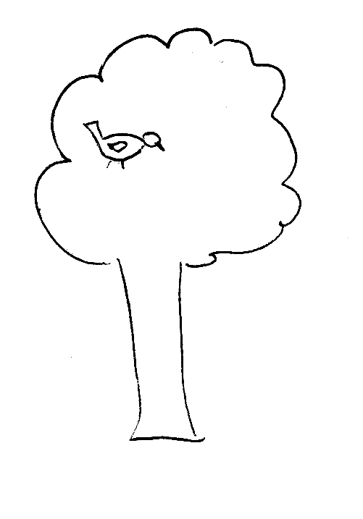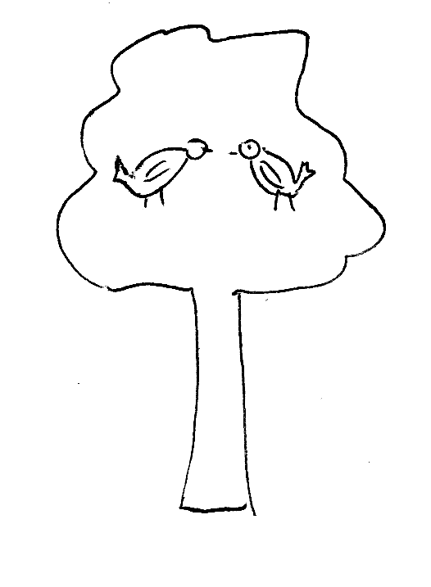
There is a bird on the tree. There are birds on the tree.

- Look at the picture of a bathroom below and fill the gaps in the text.
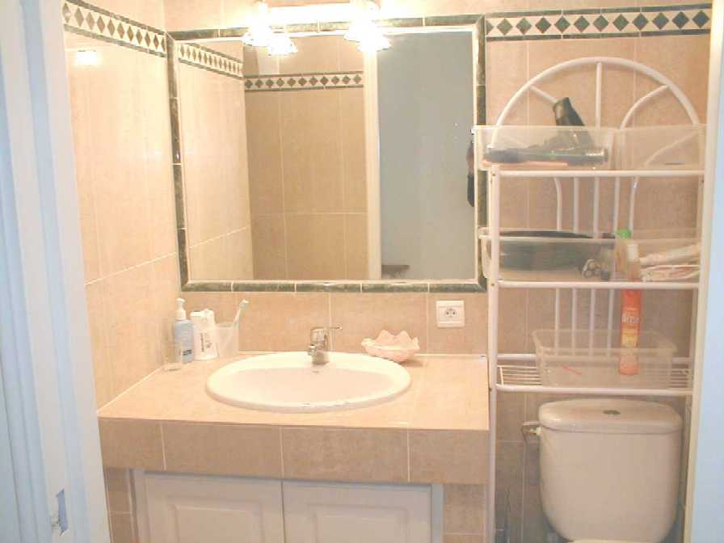

faucet, toothbrush, toilet, sink, mirror, tiles, toilet paper, soap, towels
The __________ in this bathroom are light brown. There is a __________ on the wall. There is a __________ in a cup near the ___________. There is some __________ near the sink in a corner on the left. The __________ is on the right next to the __________. There isn’t any __________ __________ near the toilet. There aren’t any __________ so you cannot dry your hands.

- Go to the following site and do the matching exercise.

http://www.eslbears.homestead.com/files/bedroom2.htm

- Match the pictures with the words from the table.

outlet, lamp, rug, bed, sheet, closet, pillow, blanket, clock radio, window shade, curtains, light switch, mattress, chest of drawers

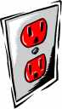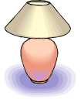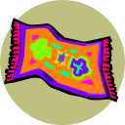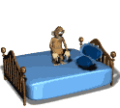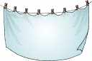
_______ _______ _______ _______ _______

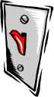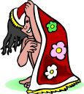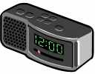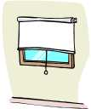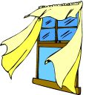
_______ _______ _______ _______ _______

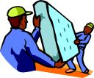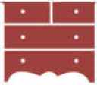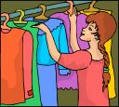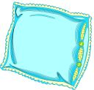
__________ __________ __________ __________

- Look at the picture of a bedroom below and complete sentences using the words from the table.

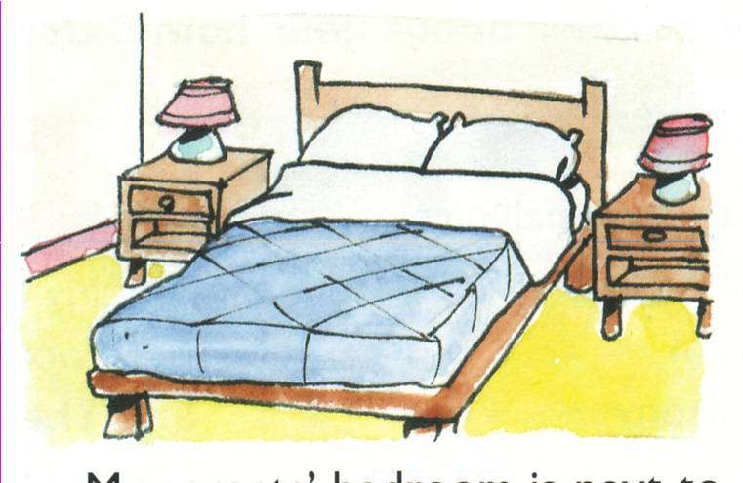

lamps, rug, bed, sheet, closet, pillows, blanket, clock radio, curtains, chest of drawers

- There is a big __________ in the middle of the bedroom.
- There are two white __________ on the bed.
- There is a blue __________ and white __________ on the bed.
- There are two __________ on the bedside tables.
- There isn’t any __________ in the bedroom, so you can’t keep your clothes there.
- There aren’t any __________ on the window.
- There is no __________ on the floor.
- There isn’t any __________, so you can’t tell what time it is.

WORDS TO REMEMBER:
hamper, toilet paper, mirror, toothbrush, toothpaste, bathtub, shower, sink, scales, faucet, towels, soap, medicine cabinet, toilet, tile, outlet, lamp, rug, bed, sheet, closet, pillow, blanket, clock radio, window shade, curtains, light switch, mattress, chest of drawers

