ANIMALS

- Go to the following site and do all the exercises from “Matching” to “Pairs”.
http://www.manythings.org/lulu/d3.html

- Fill the blanks with correct words from the table.

gorillas, fish, elephants, beavers, snakes, lions, penguins, cats,

- __________ like milk.
  - __________ builds dams on rivers.
  - __________ live in rivers, lakes and seas.
  - __________ are big cats that live in Africa.
  - __________ are big and black.
  - __________ are grey and have big ears.
  - __________ are very, very long.
  - __________ are black and white birds that can’t fly.

- Go to the following link and do all exercises from “Matching” to “Pairs”.

http://www.manythings.org/lulu/w3.html

- Match the words with correct pictures.

bird, cow, crocodile, deer, horse, otter, pig, porcupine, squirrel

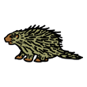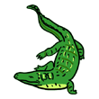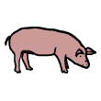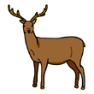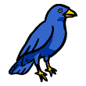
__________ __________ __________ __________ __________

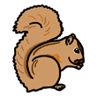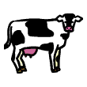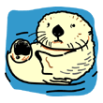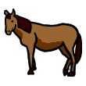
__________ __________ __________ __________

- Go to the following link and do all exercises from “Matching” to “Pairs”.
http://www.manythings.org/lulu/v3.html
- Fill the blanks with following words.
kangaroo, koala, leopard, rhinoceros, tiger, zebra
- __________ are wild cats with black stripes on their bodies.
- __________ are wild cats that can climb trees.
- __________ live in Australia, climb trees and eat eucalyptus.
- __________ live in Australia and can jump very well.
- __________ have black and white stripes on their bodies.
- __________ has horns on its head.
- Go to the following link and do all exercises from “Matching” to “Pairs”.
http://www.manythings.org/lulu/u3.html
- Match the pictures with the words from the table.
crab, dolphin, duck, frog, lobster, oyster, shark, turtle, whale
 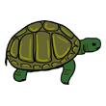 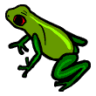 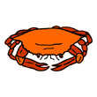 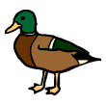__________ __________ __________ __________ __________
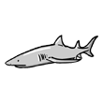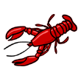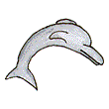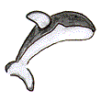
__________ _________ __________ __________

- Go to the following link and do the matching exercises.
http://iteslj.org/v/ei/animals.html
http://www.eslbears.homestead.com/files/animals.htm

- Go to the site below and solve the crossword puzzle.
http://iteslj.org/cw/2/cr-farmanimals.html

- Now do the spelling exercise.

http://www.manythings.org/cts/8975.html

WORDS TO REMEMBER

gorilla, dog, fish, elephant, beaver, snake, lion, penguin, cat, bird, cow, crocodile, deer, horse, otter, pig, porcupine, squirrel, bear, kangaroo, koala, leopard, lion, monkey, rhinoceros, tiger, zebra, bear, kangaroo, koala, leopard, lion, monkey, rhinoceros, tiger, zebra

